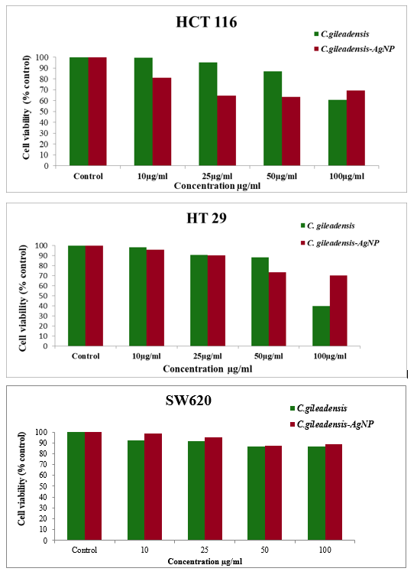

**Figure 4. Cytotoxicity of *C. gileadensis* extract and *C. gileadensis* AgNP extract against human colon cancer cell line HTC116, HT29 and SW620.**